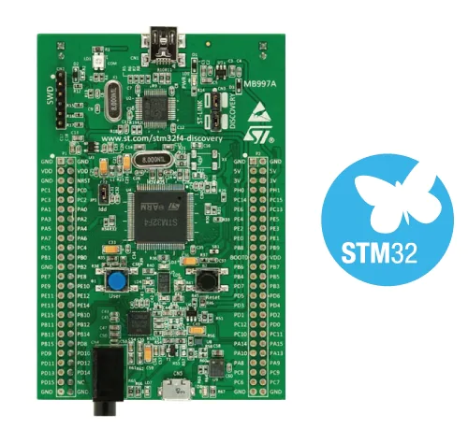
STM32 BOARD

STM32F4DISCOVERY

All features

- STM32F407VGT6 microcontroller featuring 32-bit Arm® Cortex®-M4 with FPU core, 1-Mbyte Flash memory and 1 92-Kbyte RAM in an LQFP100 package
- ST MEMS 3-axis accelerometer
- ST-MEMS audio sensor omni-directional digital microphone
- Audio DAC with integrated class D speaker driver
- User and reset push-buttons
- Eight LEDs:
LD1 (red/green) for USB communication
LD2 (red) for 3.3 V power on
Four user LEDs, LD3 (orange), LD4 (green), LD5 (red) and LD6 (blue)
- Two USB OTG LEDs, LD7 (green) VBUS and LD8 (red) over-current
- Board connectors:

- USB with Micro-AB, Stereo headphone output jack
- 2.54 mm pitch extension header for all LQFP100 I/Os for quick connection to prototyping board and easy probing
- Flexible power-supply options: ST-LINK, USB VBUS, or external sources
- External application power supply: 3 V and 5 V
- Comprehensive free software including a variety of examples, part of STM32CubeF4 MCU Package, or STSW-STM32068 for using legacy standard libraries
- On-board ST-LINK/V2-A debugger/programmer with USB re-enumeration capability: mass storage, Virtual COM port, and debug port
- Support of a wide choice of Integrated Development Environments (IDEs) including IAR Embedded Workbench®, MDK-ARM, and STM32CubeIDE

